QUES/-1:

#include<iostream>

#include<fstream>

#include<stdlib.h>

using namespace std;

int main(int argc, char *arg[])

{

string a;

ifstream FileName;

FileName.open(arg[1]);

while(getline(FileName, a))

{

cout<<a;

}cout<<endl;

return 0;

}

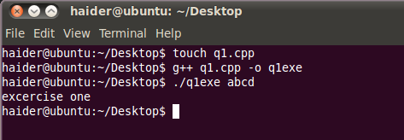

QUES/-2:

#include<iostream>

#include<fstream>

#include<stdlib.h>

#include<string>

using namespace std;

int main(int argc, char *arg[])

{

int i=1;

char* temp;

for(; i<argc; i++)

{

for(int j=i+1; j<argc; j++)

{

if(atof(arg[i])>atof(arg[j]))

{

temp=arg[i];

arg[i]=arg[j];

arg[j]=temp;

}

}

}

for(int x=1; x<argc; x++)

{

cout<<arg[x]<<" ";

}cout<<endl;

return 0;

}

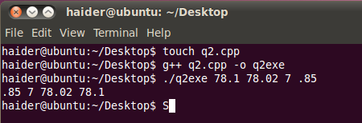

QUES/-3:

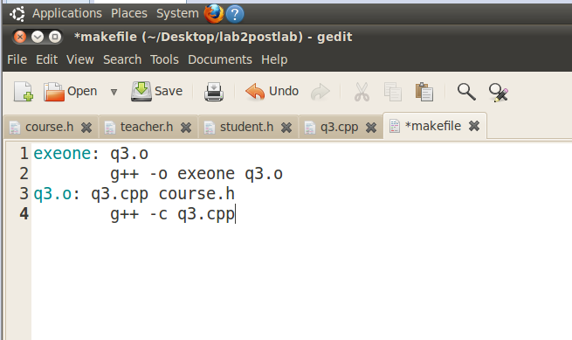

Course.h:

#include<iostream>

#include<string>

#include"teacher.h"

#include"student.h"

using namespace std;

class Course

{

public:

Course(int s, int t);

void set_course_name(string c_name);

string get_course_name();

Teacher* c_teacher;

Student* c_student;

void print_course();

int t;

int s;

private:

string course_name;

};

void Course::print_course()

{

cout << "course name:" << get_course_name() << endl;

cout << "teacher/s :";

for (int i = 0; i < t; i++)

{

cout<<c_teacher[i].get_teacher_name()<<" ";

}

cout << "\nstudent/s :";

for (int i = 0; i < s; i++)

{

cout << c_student[i].get_student_name()<<i<<" ";

}

cout << endl;

}

Course::Course(int st, int te)

{

s = st;

t = te;

c_teacher = new Teacher[te];

c_student = new Student[st];

}

string Course::get_course_name()

{

return course_name;

}

void Course::set_course_name(string c_name1)

{

course_name = c_name1;

}

student.h:

#include<iostream>

#include<string>

using namespace std;

class Student

{

public:

Student();

void set_student_name(string s_name);

string get_student_name();

private:

string student_name;

};

Student::Student()

{

}

string Student::get_student_name()

{

return student_name;

}

void Student::set_student_name(string s_name)

{

student_name = s_name;

}

Teacher.h:

#include<iostream>

#include<string>

using namespace std;

class Teacher

{

public:

Teacher();

//~teacher();

void set_teacher_name(string t_name);

string get_teacher_name();

private:

string teacher_name;

};

Teacher::Teacher()

{

}

string Teacher::get_teacher_name()

{

return teacher_name;

}

void Teacher::set_teacher_name(string t_name)

{

teacher_name = t_name;

}

Q3.cpp:

#include <iostream>

#include<string>

#include"course.h"

using namespace std;

int main(int argc, char* arg[])

{

int s = 20;

int t = 2;

Course* OS = new Course(s,t);

OS->set_course_name("operating system");

OS->c_teacher[0].set_teacher_name("abuzar");

OS->c_teacher[1].set_teacher_name("bilal");

string v = "A";

for (int i = 0; i < s; i++)

{

OS->c_student[i].set_student_name(v);

}

OS->print_course();

return 0;

}

Makefile:

exeone: q3.o

g++ -o exeone q3.o

q3.o: q3.cpp course.h

g++ -c q3.cpp

